📘 Telco Customer Churn Analysis Report

Project Overview:
The project aims to analyze customer churn in a telecommunications company and develop predictive models to identify at-risk customers. The ultimate goal is to provide actionable insights and recommendations to reduce churn and improve customer retention.
Dashboard 1: Churn Rate Overview
Overview:
The first dashboard provides a comprehensive summary of the company’s churn performance, highlighting overall churn rate, total customers, churned customers, and key patterns across contract types, payment methods, internet services, and tenure.
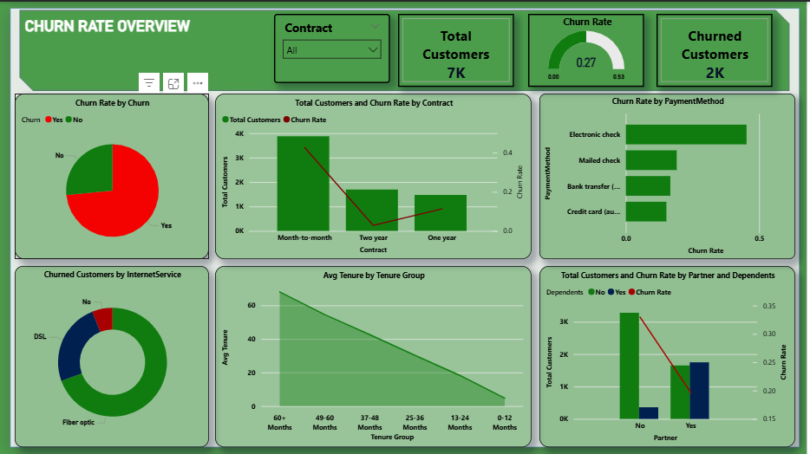Fig 1. Churn Rate Overview
Key Insights
- Churn by Partner Status: Customers without partners churn more frequently, showing that shared households are more stable.
- Tenure Distribution: Newer customers have the highest churn — first 6 months are critical. Longer-tenure customers (60+ months) show stronger loyalty.
- Churn by Internet service: Customers with Fiber Optic internet churn more frequently compared to those using DSL.
- Churn by Contract Type: Month-to-month contracts have the highest churn, while two-year contracts retain most customers.
- Payment Method: Electronic check users have a higher churn tendency compared to credit card and bank transfer users.
Summary
- Retention should target month-to-month customers and electronic check users.
- Offer discounts for long-term contracts or switch-to-auto-payment campaigns to reduce churn.
- Offering first-year retention incentives (discounts, loyalty points, or personalized offers).
Dashboard 2: Sales & Revenue Insights
Overview:
The second dashboard explores churn through the lens of customer demographics — gender, senior citizen status, dependents, phone service, and streaming TV usage.
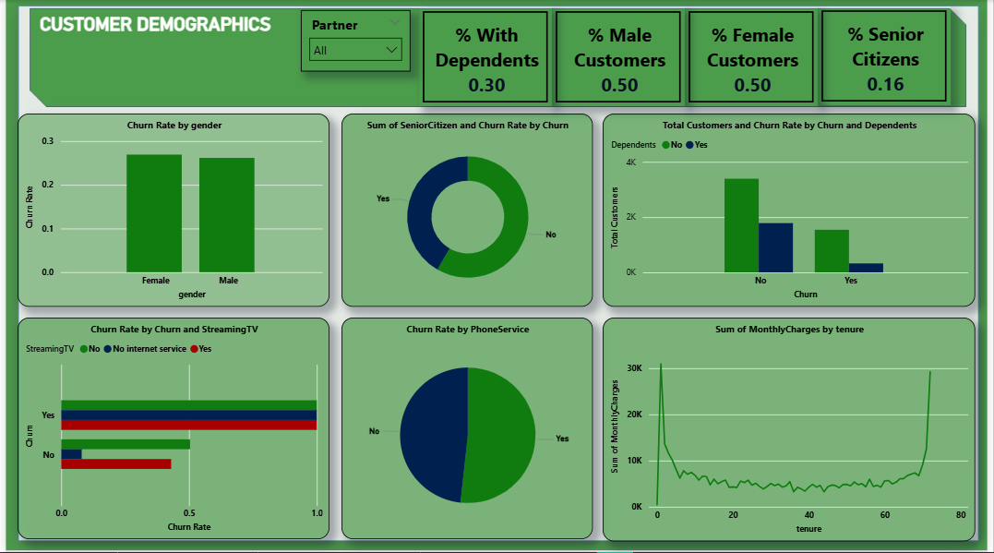
Fig 2. Customer Demographics

Key Insights
- Customer Distribution: Balanced male-female ratio, showing no gender bias in subscription trends.
- Churn Rate by Streaming TV – customers without internet services show minimal churn.
- Monthly Charges vs Churn: Higher monthly charges correlate with higher churn, suggesting price sensitivity.
- Senior Citizen vs Churn: Senior citizens show slightly higher churn likelihood.
- Additional Services: Customers with multiple add-ons (security, tech support) show stronger loyalty.

Summary
To improve revenue retention:
- Focus on onboarding and early-stage engagement for new customers.
- Promote bundled services and loyalty programs.
- Offer discounts or rewards for high-charge customers to boost satisfaction.
- Develop customer retention campaigns focused on senior citizens and single households.

Dashboard 3: Churn Probability & Prediction
Objective:
To use the machine learning model’s predictions to identify customers most likely to churn.
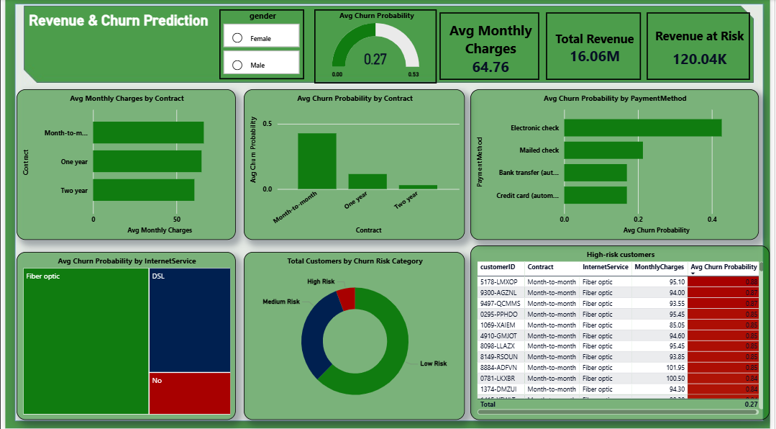Fig 3. Revenue & Churn Dashboard

Key Insights
- Average Churn Probability: 0.27 (27%), meaning roughly 1 in 4 customers are at risk.
- High-Risk Segments:
  - Month-to-month contracts
  - High monthly charges
  - No partner or single-household customers

- Low-Risk Segments:
  - Customers with long-term contracts
  - Auto-payment methods
  - Partnered households

Summary
The predictive model aligns with descriptive trends — contract length, payment type, and household stability are key drivers of churn.
The insights enable targeted retention strategies such as:
- Personalized retention offers for 0.27+ probability customers
- Contract renewal reminders
- Loyalty perks for long-term customers

Overall Conclusion
This project combines descriptive and predictive analysis to identify the key drivers of churn in Telco’s customer base.
Top Recommendations:
- Encourage long-term contracts to stabilize revenue.
- Automate billing via credit card or bank transfer.
- Improve onboarding and early support for new customers.
- Use churn probability to prioritize retention campaigns effectively.
- Offer discounts or bundles for customers using electronic checks to reduce churn.
- Target fiber optic customers with personalized retention offers.

